model = Sequential()

model.add(Embedding(max_features, 128))

model.add(SimpleRNN(128, dropout=0.2, recurrent_dropout=0.2))

model.add(Dense(1, activation='sigmoid'))

model.summary

Epoch 15/15

782/782 [==============================] - 225s 288ms/step - loss: 0.3730 - accuracy: 0.8438 - val_loss: 0.5772 - val_accuracy: 0.7482

782/782 [==============================] - 14s 18ms/step - loss: 0.5772 - accuracy: 0.7482

Test score: 0.5772409439086914

Test accuracy: 0.748199999332428

Time required for training: 0:56:18.365174

. 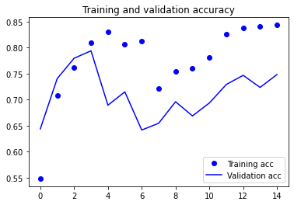

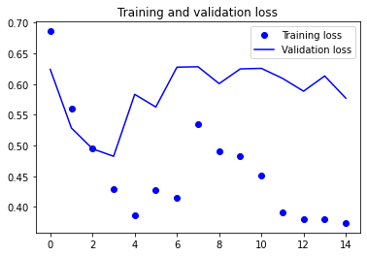

model = Sequential()

model.add(Embedding(max_features, 128))

model.add(LSTM(128, dropout=0.2, recurrent_dropout=0.0, recurrent_activation="sigmoid", activation="tanh",use_bias=True, unroll=False,))

model.add(Dense(1, activation='sigmoid'))

model.summary

Epoch 15/15

782/782 [==============================] - 27s 35ms/step - loss: 0.0127 - accuracy: 0.9956 - val_loss: 1.1914 - val_accuracy: 0.7778

782/782 [==============================] - 4s 6ms/step - loss: 1.1914 - accuracy: 0.7778

Test score: 1.1914094686508179

Test accuracy: 0.7777600288391113

Time required for training: 0:06:47.798215

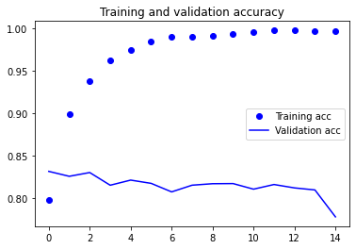

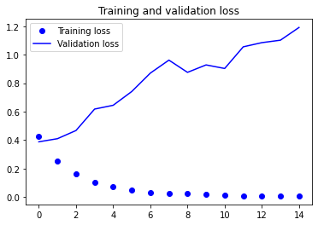

model = Sequential()

model.add(Embedding(max_features, 128))

model.add(Bidirectional(LSTM(128, dropout=0.2, recurrent_dropout=0.0, recurrent_activation="sigmoid", activation="tanh",use_bias=True, unroll=False,)))

model.add(Dense(1, activation='sigmoid'))

model.summary

Epoch 15/15

782/782 [==============================] - 37s 47ms/step - loss: 0.0066 - accuracy: 0.9977 - val_loss: 1.2550 - val_accuracy: 0.8115

782/782 [==============================] - 6s 8ms/step - loss: 1.2550 - accuracy: 0.8115

Test score: 1.2549850940704346

Test accuracy: 0.8114799857139587

Time required for training: 0:09:19.931479

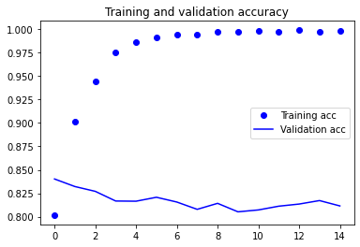

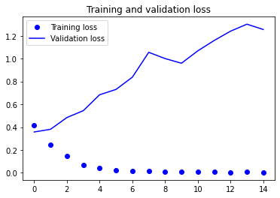

model = Sequential()

model.add(Embedding(max_features, 128))

model.add(GRU(128, dropout=0.2, recurrent_dropout=0.0, recurrent_activation="sigmoid", activation="tanh",use_bias=True, unroll=False,reset_after=True))

model.add(Dense(1, activation='sigmoid'))

Epoch 15/15

782/782 [==============================] - 22s 29ms/step - loss: 0.0054 - accuracy: 0.9982 - val_loss: 1.3254 - val_accuracy: 0.8108

782/782 [==============================] - 4s 5ms/step - loss: 1.3254 - accuracy: 0.8108

Test score: 1.3253533840179443

Test accuracy: 0.8107600212097168

Time required for training: 0:05:42.206800

